**BACKGROUND TASK**

Here is your task

It’s omnipresent: telecom marketing. Better price here. Better service there. Best for small businesses here. Best for young urbanites there. But what do customers really want? Our client, a big telecom company needs to know. This email just arrived for you:

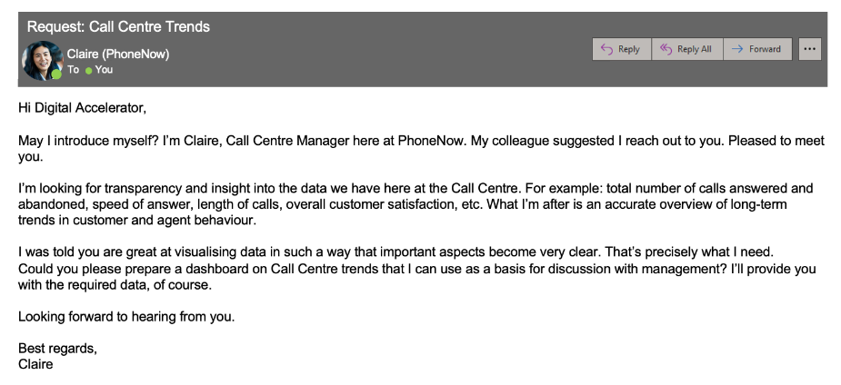

Create a dashboard in Power BI for Claire that reflects all relevant Key Performance Indicators (KPIs) and metrics in the dataset. Get creative!

**Possible KPIs include (to get you started, but not limited to):**

* Overall customer satisfaction
* Overall calls answered/abandoned
* Calls by time
* Average speed of answer
* Agent’s performance quadrant -> average handle time (talk duration) vs calls answered